SLOVAK ASSOCIATION OF NATURAL BODYBUILDING
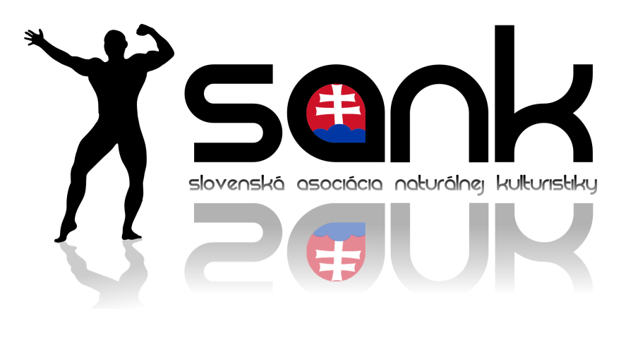

RULES AND REGULATIONS
IX. Victoria Natural Cup

Organizer: delegated by SANK committee – ŠK Victoria
Place: Sports Hall Viničné, Družstevná 1
Date: 15. 10. 2022
Promoter of competition: Viliam Rigo

Applications to be sent electronically by 10.10.2022 https://www.zbodyfit.com/competition/cestne-prehlasenie.php?sutaz=143&lang=sk
Phone number: +421917812810
E-mail: rigosank@gmail.com

Technical instructions:
Judging criteria: The competition will follow current judging criteria of SANK.
https://www.sank.sk/sutazne-pravidla-sank/

Conditions of competing:
- valid membership card (ID, passport)
- paid annual licence
- filled and in time sent electronc application

Payments:
- starting fee 50 EUR and contribution for doping 20 EUR
- backstage coach pass 5 EUR
- ticket 10 EUR

Notice: Athlete is required to undergo doping control when call upon. In case of declining or positive test result will the athlete be considered as positive and will not be able to participate in competitions of natural bodybuilding and fitness. Sanctions are given based on current guidelines. The promoter of competition will create an environmnet for doping control.

Objections: Athlete can object by paying a 10 EUR fee. The legitimacy of objection will be consulted by committee of appeal composed of: head judge, promoter of competition and SANK delegate.

Staff:
- Organizer of competition: Viliam Rigo
- Promoter of competition: Viliam Rigo
- Head of backstage crew: Martin Vrbjar
- Health service:
- MC: Peter Juriga
- DJ: Elko

Judges:
Head judge: Ján Berdy
Administrator of head judge: Ľuboš Zeman
Judges panel: 5 members

Time schedule:
14.10. 2022 17:00 – 20:00 – athletes check-in

15.10. 2022 07:00 – 09:00 - athletes check-in
09:00 – 9:45 – judges meeting
10:00 – 20:00 - semifinale and finale of all categories
The times are only informative, it depends on the number of athletes.

Conditions of competition:
- athletes compete following the current judging criteria of natural bodybuilding and fitnes, without use of banned substances and following the antidoping code
- athlete fully accepts the rules of competitions and its consequences in case of breaching them
- if organizer finds that athlete does not fulfil the competition rules, the athlete will be disqualified
- athletes compete at their own reponsibility
- it is only possible to register for competition electronically by the date stated – after online registration closes it is possible to register at the athletes check-in with a fee of 10 EUR

Other information
Athletes come to check-in with valid membership card with valid licence (foreign athletes with ID or passport). Athletes who compete in categories with posing routines bring a flash drive with one song for the posing routine, in case they didn’t upload their music to the electronic application. Female athlete will bring their shoes and posing swimsuit.

Allowed platform is 2.5 cm and heel max. 13cm. Bikini cannot be of thong cut. Sport Model cannot have brands (Nebbia, Nike, Adidas, etc.) on their posing clothes. Allowed shoes are sports shoes withou platform.
Men’s Physique and Classic Physique posing trunks cannot have brands on them. Men’s Bodybuilding posing suit has to be 2cm wide on the sides. Athlete who does not fulfil these criteria will not be allowed to compete.

IMPORTANT INFORMATION:
BASED ON THE LAW OF SPORT 440/2015 Z.z. ATHLETES ARE REQUIRED TO SUBMIT A CONFIRMATION F THEIR MEDICAL WELL BEING.
If needed the document can be found on our website www.sank.sk

To enter bacstage will be only allowed to athletes and coaches who’ll have their backstage passes. They are required to where these passes and if asked by the organizer of the competition show their ID.
The organizer is not responsible for any loss of valuable and personal things or money.
We ask the athletes and coaches to be careful and not damage the interier and exterier of the competition with their spray tan – the damaged caused will be paid by the person who caused it. There is a fine of 50 EUR for causing damage at the place of competition.
Accomodation and alimentation is on athletes‘ cost.

To book PRO TAN spray tan: https://protansk.sk/rezervace_SANK/
DREAM TAN colour is not allowed!

Prizes:
Competitor placed 1st-3rd in each category win medals, diploms and other prizes.

Other:
https://www.facebook.com/SANKSlovakia
https://www.instagram.com/sank_sk/
https://www.facebook.com/events/1034490513919399/?active_tab=discussion

Press accreditation: Press members should send their applications for accredition to e-mail: rigosank@gmail.com

Categories:
www.zbodyfit.com/competition/cestne-prehlasenie.php?sutaz=143&lang=sk

Organizer is allowed to add, merge or cancel a category if there is insufficient number of competitors – at least 3 athletes have to be registered in each category.

Rules and regulations written by: www.sank.sk

Organizer of competition: Viliam Rigo

